“Tapping the Future” – CSC Student Design Challenge 2019/2020
A site has been Selected!
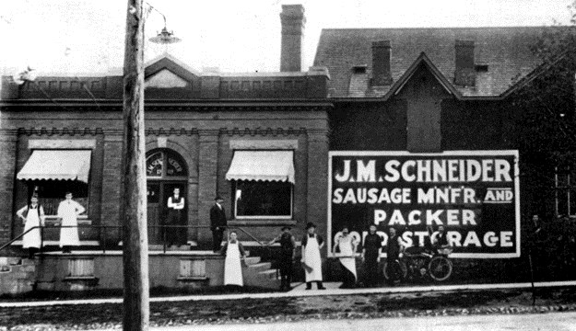Construction Specifications Canada (CSC) Grand Valley and Toronto Chapters are thrilled to present the 7th Annual Student Design Challenge. Every year we choose a site that is currently being re-imagined and repurposed: a building that is relevant because of its’ historical story and importance to the community.
This year, we have selected a building that was once part of the JM Schneider Meat Processing Compound. The building originally served as the office but over the years’ morphed into the garage where the Schneider’s fleet of cars and trucks were maintained. It is a 30,000 sf. rectangular red brick building built in 1948.

The story really begins in 1890. John Metz Schneider, an immigrant from Germany, founded a meat packing company in Kitchener. For over 125 years, JM Schneider’s has employed 1000’s of people from the community. People worked at Schneider’s their entire lives, they met; they married and had children who followed in their footsteps. JM Schneider contributed to the fabric of the community and city. There is much more to the history than just the building. Check out this link to the Schneider’s Employee website: http://www.schneidersgac.ca/

Students from post-secondary schools in Ontario are asked to design the space with a focus on hospitality while embracing the Schneider legacy. Dare to dream with no budgetary constraints.
The requirements are that they incorporate 5 of the 10 product categories and write one specification for one of those products. Competition requirements will be listed on the website: www.cscdesignchallenge.ca.

Along with being recognized in the National Kenilworth Publication, Construct Canada, the top five entries will be showcased and announced at an awards ceremony in May 2020.

1st place: $2,000.00
2nd place: $1,000.00
3rd place: $500.00

Planitar has once again partnered with the Student Design Challenge. They have virtually mapped the site allowing students to access accurate drawings.
Details can be found on their iGuide: https://goiguide.com/csc

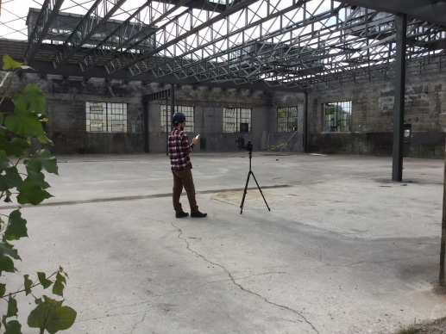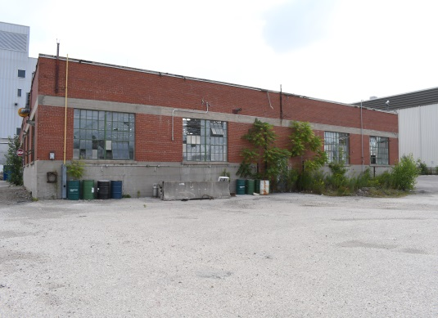

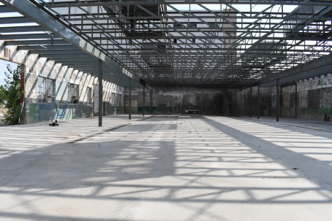

The 27 acre property was purchased by Auburn Developments in 2017. They are preserving 3 of the buildings, one of which is the site of the competition. Their vision for the site, recently branded “The Metz”, as a nod to the Schneider’s founder, is expected to accommodate 2,800 new residential units and 700 jobs. The proposed development will transform the Rockway neighbourhood. It will include a range of low, mid and high-rise housing options, street-front retail spaces as well of office, restaurants and commercial uses.
The Vision
(The red brick building is directly behind the office building facing Courtland Avenue.)

2020 CSC Student Design Challenge Committee Members:
Co-Chairs: Isabelle Champagne and Cathie Schneider, Susan Cunha, Iain Stuart, Ashley MacKay

